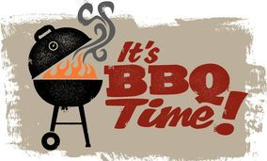

FRIDAY 25TH JUNE
FROM 545PM TILL LATE



COME AND SUPPORT
the under19s in
THE FIRST 100 BALL MATCH
ON THE CBCC GROUND
STARTING AT 6 PM

Burgers £4
Sausage baps £3
Chips £2
Cash only please

